**Experiment-2.2**

# Student Name: SANSKAR AGRAWAL UID: 20BCS5914

**Branch: CSE Section/Group:** **20BCS_MM_806-B**

**Semester: 5 Date of Performance: October 16, 2022**

# Subject Name: Multimedia Technologies Lab Subject Code: 20CSP-339

**Aim-** Given a picture, make three copies of this picture. On one of these pictures, adjust the brightness and contrast, so that it gives an elegant look. On the second picture, change it to grayscale and the third is the original one using photopea**.**

**Hardware Requirements:**

Minimum 384 RAM, 100GB hard disk, processor with 2.1MHz.

**Software Requirements:**

Photopea.

**Tools Used:**

Brightness & contrast, Hue/Saturation.

**Steps :**

1. Open Photopea and select the white background.

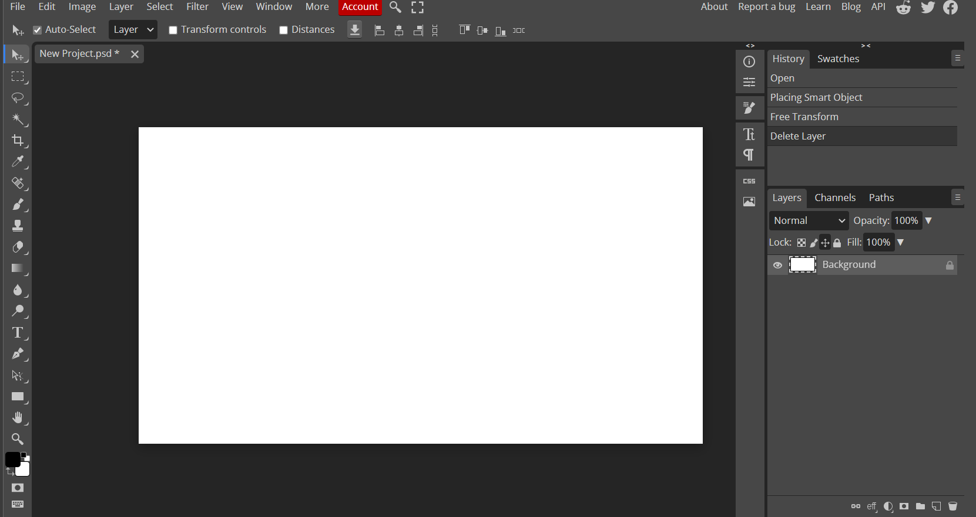

1. Choose any photo or you can also drag it.

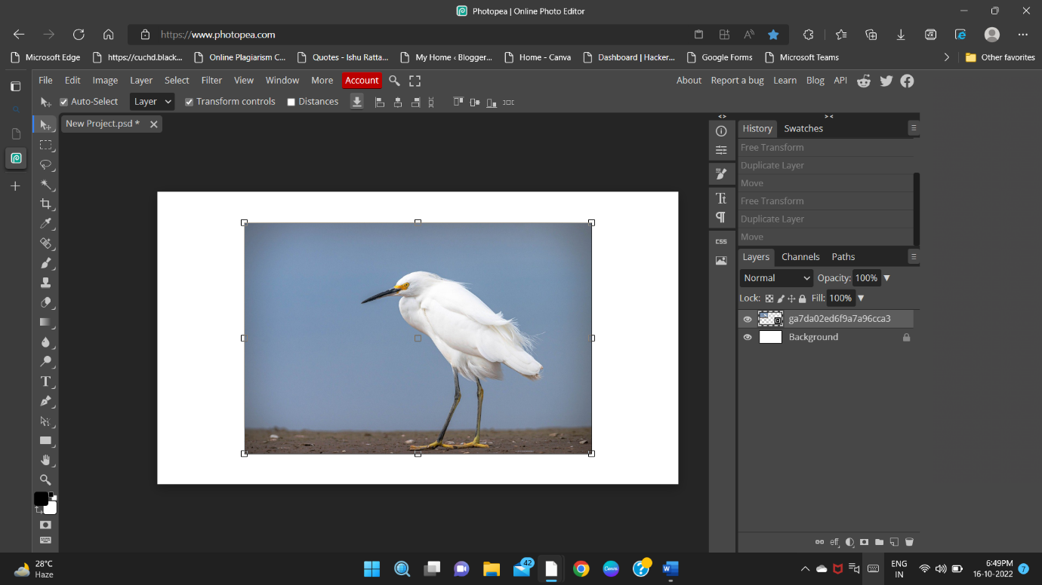

1. Make 2 more copies of same photo to show the difference after editing.

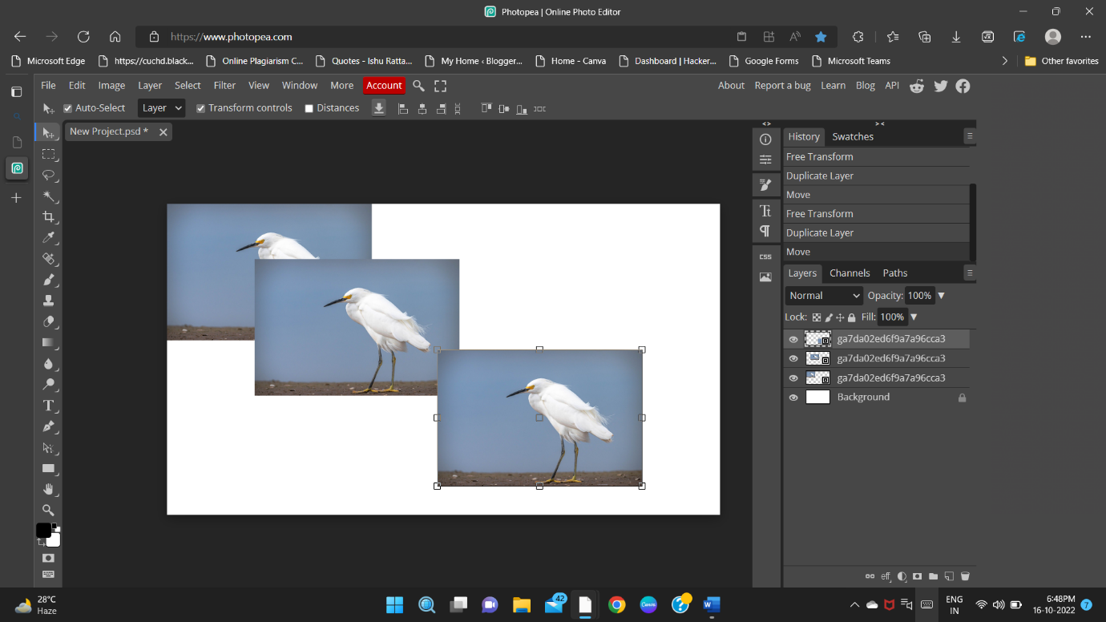

1. Before start editing make sure that your layer is rasterize.

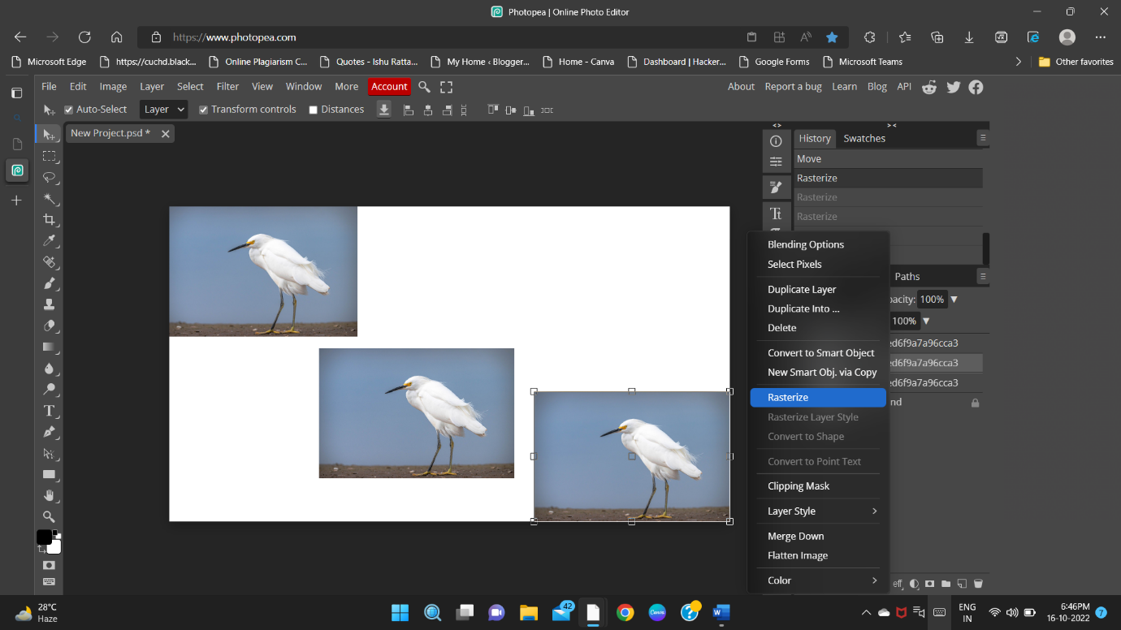

1. Then at first image, Go to

Image -> Adjustments -> Brightness / Contrast.

Then edit the image as you want. Adjust the parameters.

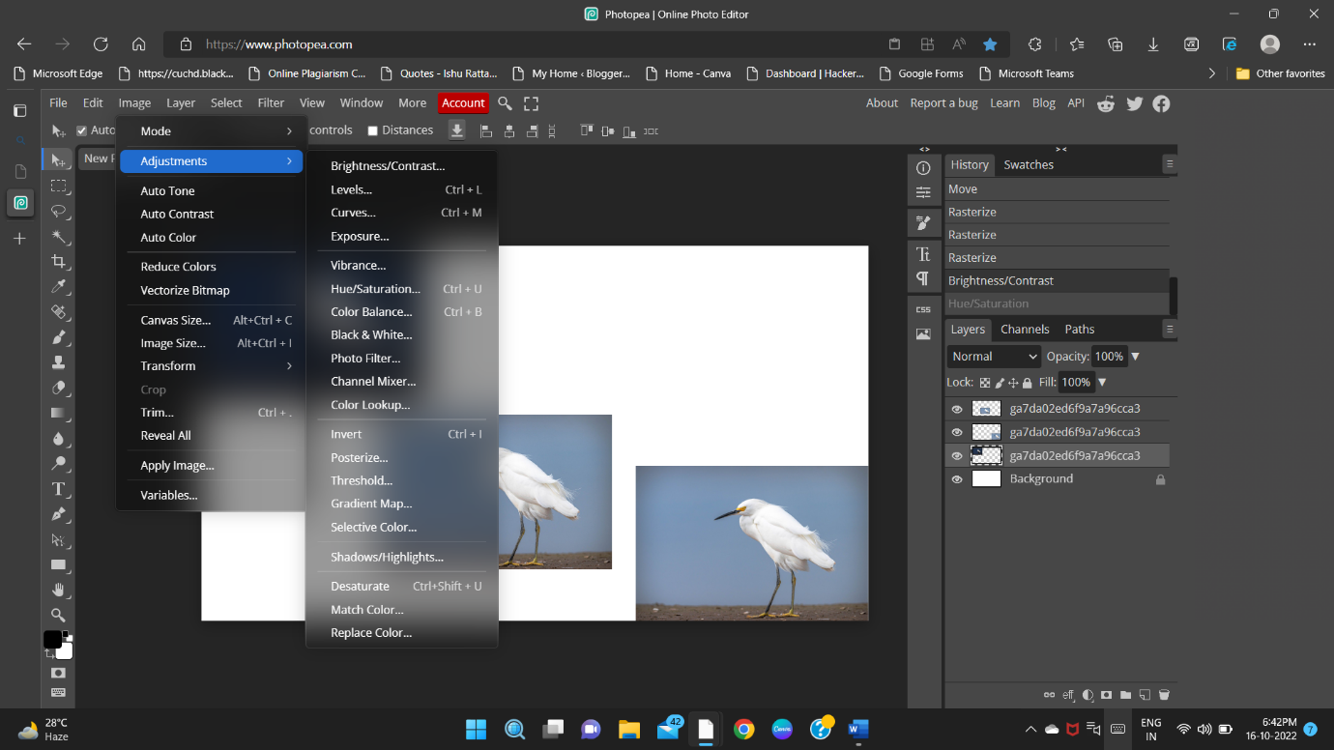

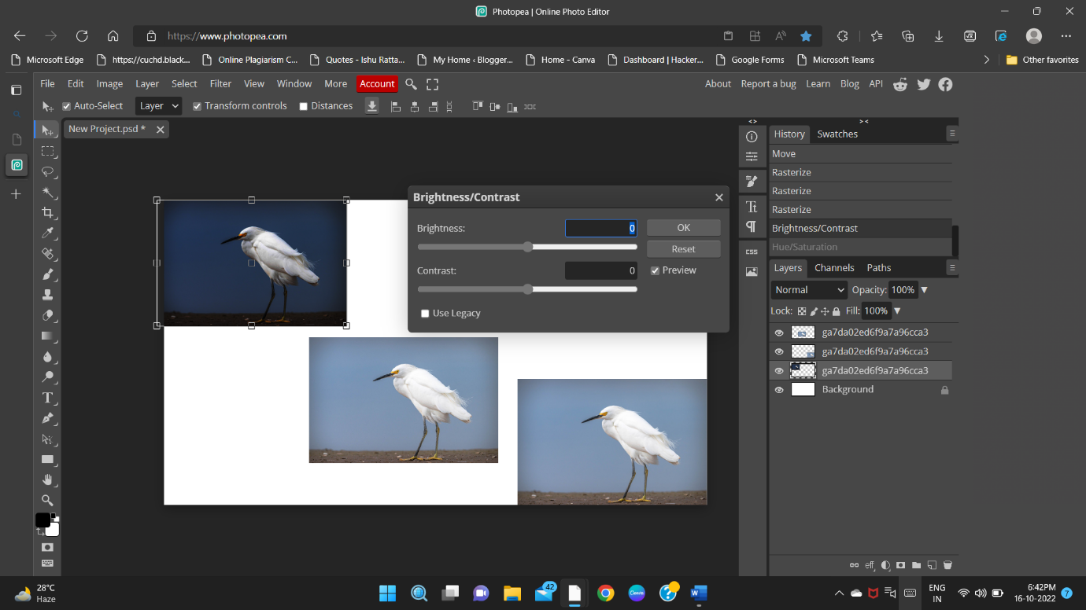

1. Then For second image, Go to

Image -> Adjustments-> Hue/Saturation.

Then adjust the parameter as you want.

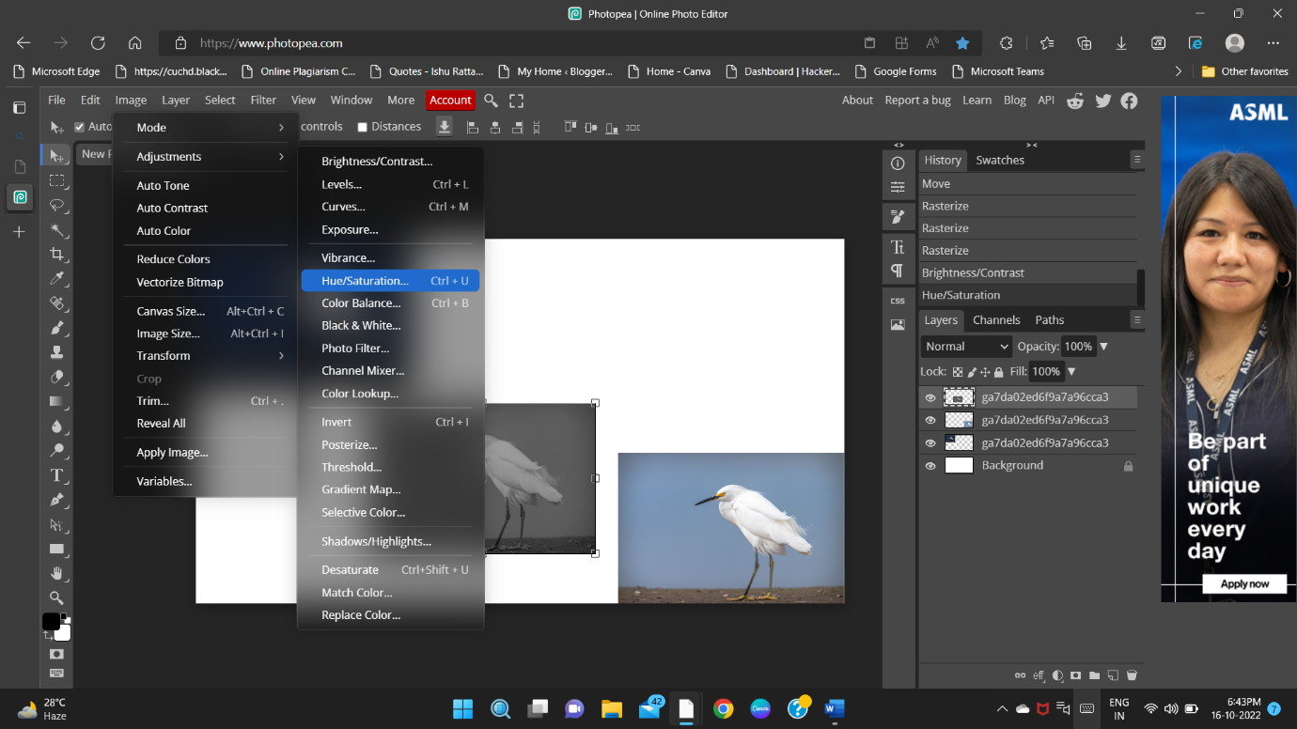

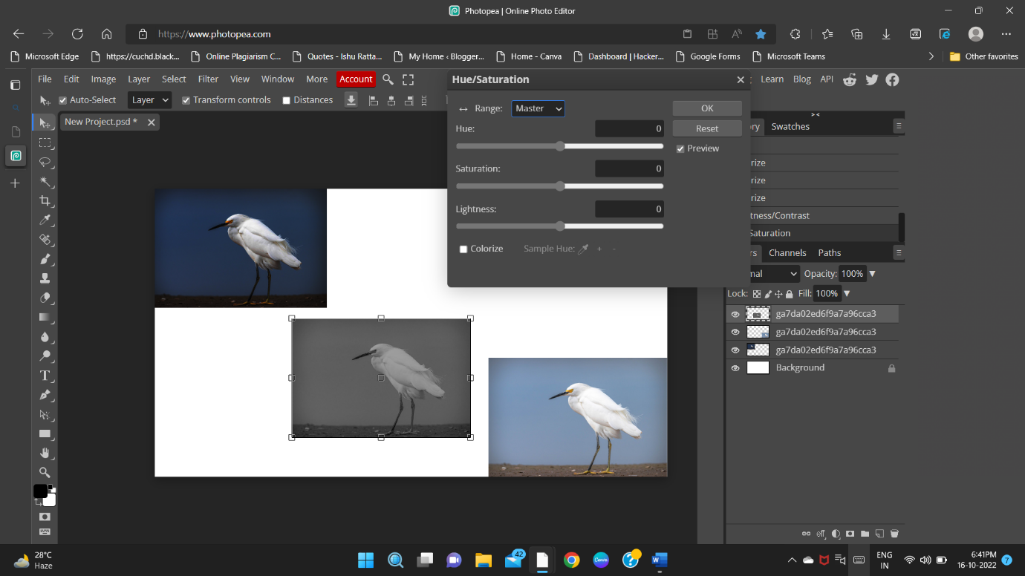

1. Keep the third image as original to show the difference in edited image and original image.

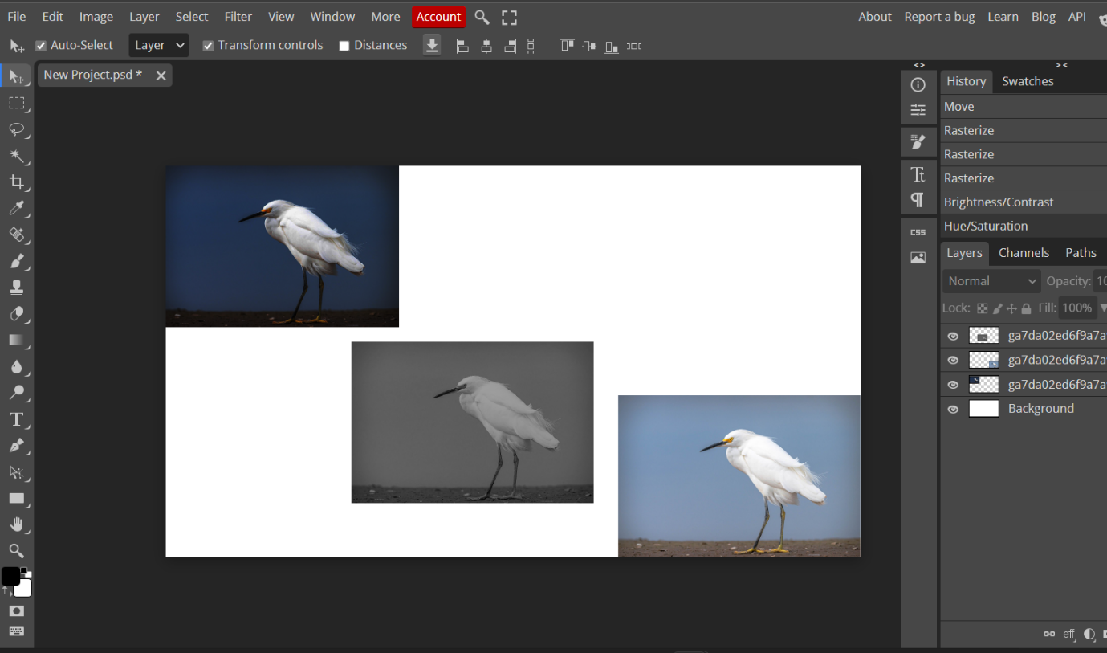

**Final Image-**

